# Problem 3.3

**Kilam’s laptop has 2GB of RAM; Liamsi’s has 4GB of RAM. Determine which of these propositions is T.**

1. **IF Kilam has more RAM than Liamsi THEN pigs can fly.**
2. **IF Liamsi has more RAM than Kilam, THEN pigs can fly.**
3. **Kilam has more RAM than Liamsi AND pigs can fly.**
4. **Kilam has more RAM than Liamsi OR pigs can fly.**
5. **Liamsi has more RAM than Kilam AND pigs can fly.**
6. **Liamsi has more RAM than Kilam OR pigs can fly.**

We know that Liamsi has more RAM than Kilam because 4 > 2. We can also assume that pigs cannot fly.

Statements a and b are false because we are not given enough information to state an implication – we are not give any information that relates amounts of RAM to pigs being able to fly.

Statements c and d are false because Kilam has less RAM than Liamsi and pigs cannot fly. Both statements are false so neither the AND or OR conditions are satisfied.

Statement e is false because while Liamsi has more RAM than Kilam, pig’s cannot fly so the AND statement is not satisfied.

Statement f is true because while pig’s cannot fly, Liamsi has more RAM than Kilam, so the OR statement is satisfied.

# Problem 3.21(c)

**Use ¬, ∧, ∨ to give compound propositions with these truth-tables.**

**c.**

|  |  |  |  |
| --- | --- | --- | --- |
| P | Q | R | ? |
| T | T | T | F |
| T | T | F | F |
| T | F | T | F |
| T | F | F | F |
| F | T | T | F |
| F | T | F | T |
| F | F | T | F |
| F | F | F | F |

Following the advice of the textbook, we need only focus on the case in which the output of the statement is true. In this question, the question, the statement is true when p and r are false and q is true. We can write this out as NOT p AND q AND NOT r. This translates into symbols like so:

¬p ∧ (q ∧ ¬r)

Problem 4.7(a)

Prove by contraposition (be sure to explicitly state the contrapositive): x is irrational 🡪 is irrational.

To start, we’ll assume that $\sqrt{x}$ is rational and attempt to prove that x is also rational (This is the contrapositive to the original statement).

🡪 🡪

By the definition of a rational number (a ratio between two integers), x must be rational.

# Problem 4.25(b) and DMC Problem 4.26(b)

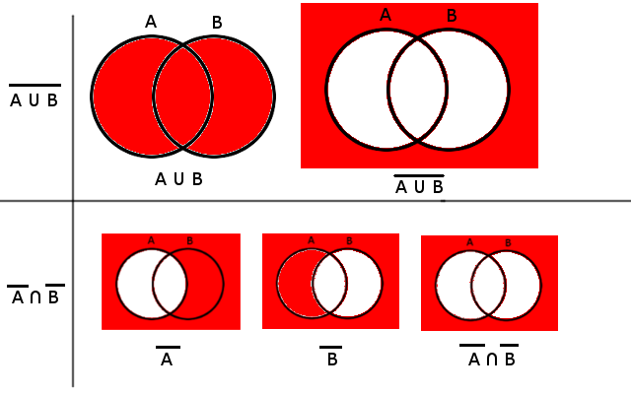**Give “proof by pictures” using Venn diagrams for each set relationship**:

**Give formal proofs for each equality in Problem 4.25.**

# Problem 4.13(l)

**(i) Prove or disprove: For every n ∈ N, n2 + n is even.**

Direct Proof:

n2 + n = n(n+1)

If n is even then n (the first term above) is even and (n+1) is odd.

If n is odd then n (the first term above) is odd and (n+1) is even.

The product of an even number and an odd number can be represented like so:

(2k)(2k-1) = 4k2 – 2k = 2(2k-k). The 2 as a leading coefficient means that the product of an odd and even number will always be even. Thus, n2 + n will always be even for every number in the set N.

# Problem 4.13(o)

(o) Prove or disprove: There exists x, y ∈ Z for which 2x2 + 5y2 = 14.